Coding quiz

There is nothing in the world of test automation that provides a better learning experience than practice.

To be a great Automation Engineer you need to...

*Practice, Fail, and Learn*

Therefore, I found an excellent place where you can practice graded coding exercises to enhance your skills.

It's not my website, but it's an excellent website, why reinvent the wheel?

**Here is what you need to do to get started, if you haven't already:**



1. If you haven't already, go here and [sign up with a free account](https://www.hackerrank.com/domains/algorithms/warmup).

2. Solve the first exercise in the Warmup section. The one called "[Solve Me First](https://www.hackerrank.com/challenges/solve-me-first/problem)". The first one is critical so that you understand how the platform works.

**If you already signed up, here is the real coding challenge:**

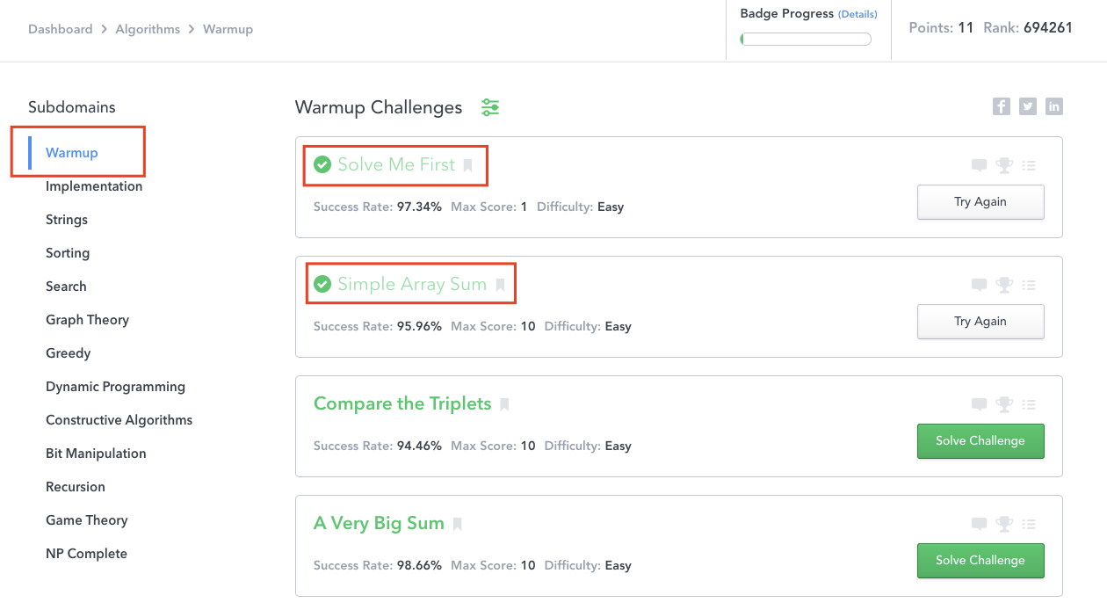

Do your best. If you don't succeed, revisit the previous videos and see what you missed.

Your code will automatically be graded in the HackerRank platform.